CO1 Assessment 03 Date: 15-10-2026
Coding Challenge
Course Code: DSA0308
Course Name: Natural Language Processing
Register No: 192324299 Haritha S

Problem 1:
Code:
import re
def validate_email(email):
pattern = r'^[A-Za-z][A-Za-z0-9._]*@[A-Za-z]+\.(com|org|edu|net|in)$'
if re.match(pattern, email):
print("Valid Email")
else:
print("Invalid Email")

def validate_password(password):
pattern = r'^(?=.*[A-Z])(?=.*[a-z])(?=.*\d)(?=.*[@#$%&!]).{8,}$'
if re.match(pattern, password):
print("Strong Password")
else:
print("Weak Password")

def validate_mobile(mobile):
pattern = r'^[6-9]\d{9}$'
if re.match(pattern, mobile):
print("Valid Mobile Number")
else:
print("Invalid Mobile Number")

email = input("Enter Email Address: ")
password = input("Enter Password: ")
mobile = input("Enter Mobile Number: ")
validate_email(email)
validate_password(password)
validate_mobile(mobile)
Output:
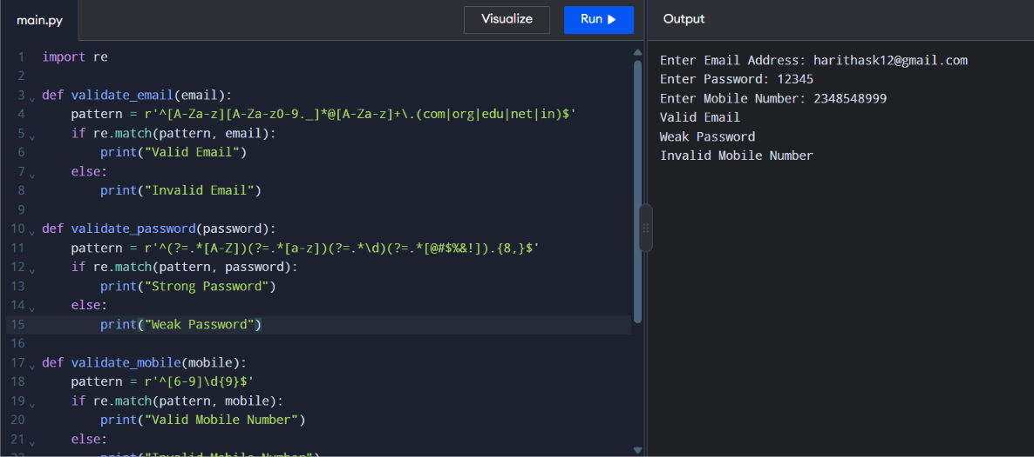

Problem 2:
Code:
states = input("Enter states (comma-separated): ").split(",")
alphabet = input("Enter input alphabet (comma-separated): ").split(",")
initial_state = input("Enter initial state: ")
final_states = input("Enter final states (comma-separated): ").split(",")
transitions = {}
print("\nEnter transitions for each state and input symbol:")

for state in states:
transitions[state] = {}
for symbol in alphabet:
next_state = input(
f"Transition from {state} on {symbol}: "
)
transitions[state][symbol] = next_state
n = int(input("\nHow many input strings do you want to test? "))
for i in range(n):
string = input(f"\nEnter input string {i + 1}: ")
current_state = initial_state
path = [current_state]
valid = True
for symbol in string:
if symbol not in alphabet:
valid = False
break
current_state = transitions[current_state][symbol]
path.append(current_state)
print("Transition Path:", " -> ".join(path))

if valid and current_state in final_states:
print("Accepted")
else:
print("Rejected")
Output:
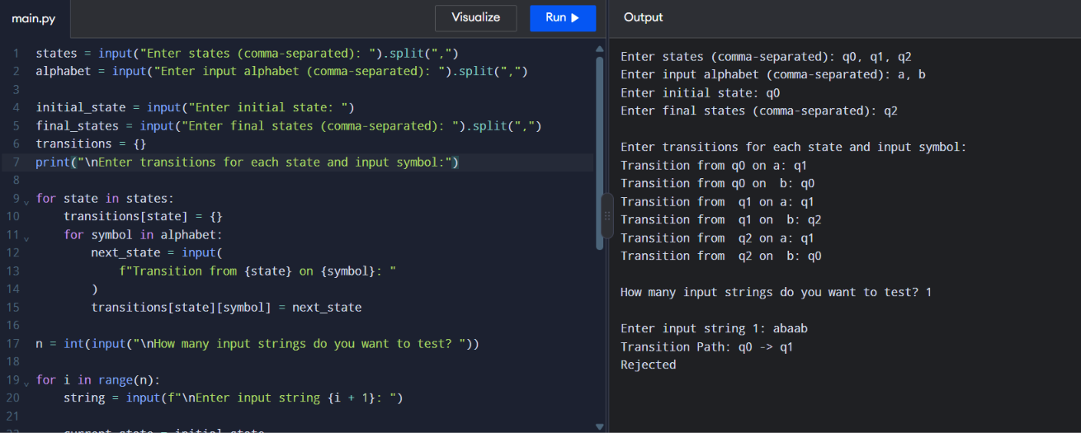

Problem 3:
Code:
import re
def pattern_search(text, choice):
patterns = {
1: (r'\b\w+\b', "Word Search"),
2: (r'\b[A-Za-z]\w*', "Prefix Search"),
3: (r'\b\w*[A-Za-z]\b', "Suffix Search"),
4: (r'\b\d{2}/\d{2}/\d{4}\b', "Date Search"),
5: (r'\b[6-9]\d{9}\b', "Phone Number Search"),
6: (r'#[A-Za-z0-9_]+', "Hashtag Search"),
7: (r'@[A-Za-z0-9_]+', "Mention Search")
}

pattern, name = patterns[choice]
matches = re.findall(pattern, text)
print("\n" + name + " Results:")
if matches:
for match in matches:
print(match)
else:
print("No matching patterns found.")

text = input("Enter the text to search: ")

while True:
print("\n----- User Menu -----")
print("1. Search Word")
print("2. Search Prefix")
print("3. Search Suffix")
print("4. Search Date")
print("5. Search Phone Number")
print("6. Search Hashtag")
print("7. Search Mention")
print("8. Exit")
choice = int(input("Enter your choice: "))
if choice == 8:
print("Exiting Pattern Matching Engine.")
break
elif choice in range(1, 8):
pattern_search(text, choice)
else:
print("Invalid choice. Please try again.")
Output:
